**BID DATA ANALYSIS**

**LAB 1**

**TASK 2:**

**2. How to install your own Cloudera Server?**

**Ans:**

* Firstly, download VMware Player or Oracle VirtualBox.
* Go to <http://www.cloudera.com/content/support/en/downloads/download-components/download-products.html?productID=F6mO278Rvo>

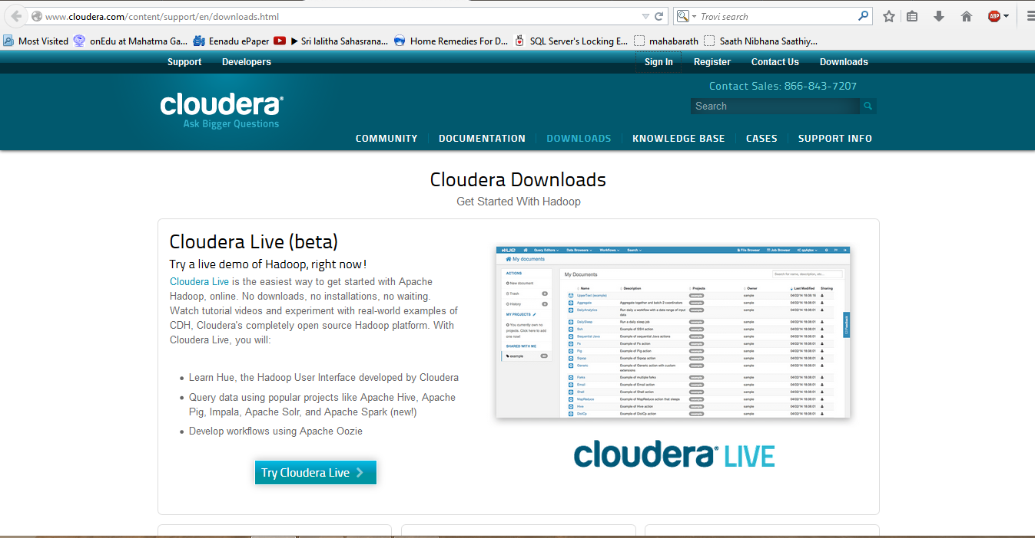

* Download cloudera image from <http://www.cloudera.com/content/support/en/downloads/quickstart_vms/cdh-5-0-x.html>

**TASK 3:**

**1. How to create an account and deploy files to GitHub?**

**Ans:**

**2. How to create an account and design projects with scrumdo?**

**Ans:** The following are the scrumDo screen shots:

* Create an organization

